Included in the source code under the DAC Packages is a file named Vegan-Poll.dacpac. This contains the database that the Moonpoll website depends on.

1. Open SSMC and log into your Database server.
2. Find the Object Explorer window and right click on the Databases folder.
3. 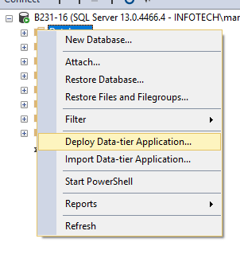Select "Deploy Data-tier Application..."
4. 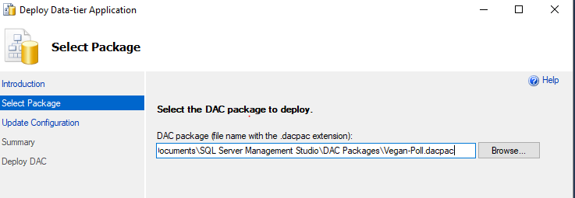In the [Deploy Data-tier Application wizard, select browse and navigate to the Vegan-Poll.dacpac file, then click next.
5. Choose a name for the database and click next.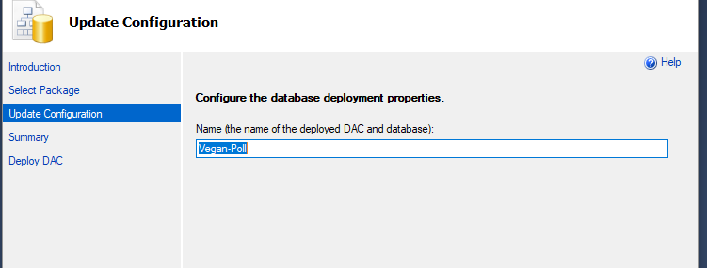
6. Click next until the wizard completes the database installation.
7. Edit the AnswerTypes table and add two records: RadioButton and Checkbox. Our website depends on this table for choosing the types of answers to our polls. You chould be able to add new answer types and edit the source code to fit your needs. 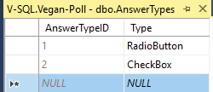
8. The source code for the project will need to be edited to point to your database server. The relevant code is located in the DBLayer project in the DBInterface.cs file. By default we designed our site to work through SQL authentication, so if you have different security requirements you’ll need to make the necessary changes to the code. 